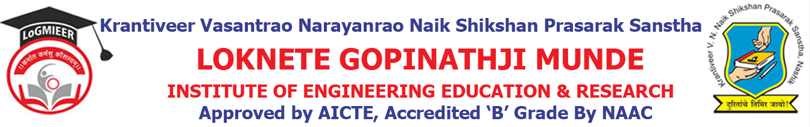
Department of AIML Engineering
ACADEMIC CALENDER-2021-22 SEM II
Sr. No. | Details of Activities | Weeks & Dates
1 | Practical Validation | Week 1 | 15/11/2021
2 | Course File & Practical File Checking | Week 1 | 15/11/2021
3 | Commencement of Teaching: TE & BE | Week 1 | 15/11/2021
4 | Commencement of Teaching: SE | Week 1 | 03/01/2022
5 | Academic letter to parent | Week 5 Onwards | 14/02/2022
6 | In-Sem Exam | Week 10 | 16/03/2022
7 | Expert Talk | Week 10 | 24/03/2022
8 | Value Added Courses/Workshop | Week 11 | 12/02/2022 to 16/04/2022
9 | Academic letter to parents | Week 03 to Week 13 | 17/01/2022 to 17/03/2022
10 | Industrial Visits | Week 03 to Week 13 | 17/01/2022 to 17/03/2022
11 | Parent Meet | Week 03 to Week 13 | 17/01/2022 to 17/03/2022
12 | Unit Test I | Week 12 | 09/03/2022 to 13/03/2022
13 | Feedback Phase | Week 16 | 15/04/2024
14 | Academic Letter to Parents | Week 16 | 15/04/2024
15 | Final TW Sub-mission | Week 16 | 15/04/2024
16 | Remedial Class | Week 16 | 24/04/2023 to 29/04/2023
17 | Conclusion of Academic: TE& BE | Week 21 | 30/04/2022
18 | Conclusion of Academic: SE | Week 18 to Week 21 | 15/05/2022
19 | Theory Exam | Week 19 Onwards

Prof. S. S. Shinde Prof. A. A. Pundlik
Academic Co-ordinator HOD

